Progress of sowing and agricultural crops details During Summer Season 2022-23.
(24.02.2023)

2022-23 Agricultural Production:

Anticipating timely and well distributed rainfall during pre-monsoon, southwest & northeast monsoon period in 2022-23 it was programmed to cover 82.67 lakh hectares, 26.68 lakh hectares and 5.20 lakh hectares during Kharif, Rabi and Summer seasons respectively, totally 114.54 lakh hectares under agricultural crops. Proposed production target for Food grains and Oilseeds were 148.02 lakh tonnes and 12.69 lakh tonnes respectively.

Sl.No. | Crops | Area (Lakh Hectares) | Production (Lakh Tonnes)
1. | Cereals | 50.45 | 123.06
2. | Pulses | 35.14 | 24.96
 | Total Food Grains | 85.59 | 148.02
3. | Oilseeds | 12.64 | 12.69
4. | Commercial Crops
i) | Cotton | 7.70 | 18.75 Lakh Bales
ii) | Sugarcane | 7.87 | 403.57
iii) | Tobacco-VFC | 0.75 | 0.66
 | Total Area | 114.54

2022-23 Kharif Agricultural Production:

During Kharif 2023 total of 82.67 lakh hectares area has been set as target for sowing under different crops.

Sl.No. | Crops | Area (Lakh Hectares) |  | Production (Lakh Tonnes)
 |  | Targeted Area | Sown Area
1. | Cereals | 35.98 | 33.69 | 97.61
2. | Pulses | 22.77 | 20.39 | 17.19
 | Total Food Grains | 58.75 | 54.08 | 114.80
3. | Oilseeds | 9.37 | 10.11 | 8.70
4. | Commercial Crops
i) | Cotton | 7.28 | 8.25 | 18.42 Lakh Bales
ii) | Sugarcane | 6.51 | 7.18 | 377.99
iii) | Tobacco-VFC | 0.75 | 0.78 | 0.66
 | Total Area | 82.67 | 80.40
2022-23 Rabi Agricultural Production:

During Rabi 2022 total of 26.68 lakh hectares area has been set as target for sowing under different crops.

Sl.No. | Crops | Area (Lakh Hectares) |  | Production (Lakh Tonnes)
 |  | Targeted Area | Sown Area
1. | Cereals | 11.15 | 9.62 | 14.67
2. | Pulses | 12.22 | 13.23 | 7.68
 | Total Food Grains | 23.37 | 22.85 | 22.35
3. | Oilseeds | 1.93 | 2.59 | 1.40
4. | Commercial Crops
i) | Cotton | 0.41 | 0.12 | 0.30 Lakh Bales
ii) | Sugarcane | 0.97 | 0.96 | 17.01
iii) | Tobacco-VFC | 0.00 | 0.00
 | Total Area | 26.68 | 26.52

2022-23 Summer Agricultural Production:

During Summer 2022-23 total of 5.20 lakh hectares area has been set as target for sowing under different crops.

Sl.No. | Crops | Area (Lakh Hectares) |  | Production (Lakh Tonnes)
 |  | Targeted Area | Sown Area
1. | Cereals | 3.32 | 3.01 | 10.78
2. | Pulses | 0.14 | 0.06 | 0.09
 | Total Food Grains | 3.47 | 3.07 | 10.87
3. | Oilseeds | 1.33 | 0.74 | 2.59
4. | Commercial Crops
i) | Cotton | 0.01 | 0.004 | 0.03 Lakh Bales
ii) | Sugarcane | 0.39 | 0.18 | 8.56
iii) | Tobacco-VFC | 0.00 | 0.00
 | Total Area | 5.20 | 3.99

Rainfall 2022:
Pre-monsoon rainfall:

During pre-monsoon (March-1 to May-31), normal average rainfall was 115 mm against actual rainfall 237 mm (105%).

Southwest monsoon rainfall:

During southwest monsoon (June-1 to September-30), normal average rainfall was 852 mm against actual rainfall 1019 mm (20%).

North-East monsoon rainfall:

During northeast monsoon (October-1 to December-30), normal average rainfall was 182 mm against actual rainfall 217 mm (19%).

Totally (January-1 to December-30) normal average rainfall was 1153 mm against actual rainfall 1474 mm (28%).

Rainfall 2023:

In 2023, from January-1st to February-24th , normal average rainfall was 4 mm against actual rainfall 1 mm (-75%). District wise rainfall data is attached in Annexure-1.

Kharif 2022 Area coverage:

During Kharif 2022, total of 80.40 lakh hectares (97%) has been sown against a set target of 82.67 lakh hectares.

Rabi 2022 Area coverage:

During Rabi 2022, total of 26.51 lakh hectares (99%) has been sown against a set target of 26.68 lakh hectares.

Summer 2022 Area coverage:
During Summer 2022, total of 3.99 lakh hectares (77%) has been sown against a set target of 5.20 lakh hectares by 24.02.2023, Crop wise and district wise area sown details was provided in annexure 2 and 3.

During 2022, an area of 11.19 lakh hectares has been damaged due to heavy rains/flood as per the reports by districts.

Supply of Agricultural Tools:

Seeds and fertilizer are the main agricultural commodities for farmers for distribution at Raitha Samparka Kendra (RSK) in all taluks.

Seeds:

For Rabi/Summer 2022-23, 4.32 lakh qtls seeds were estimated as demand for sowing and till dated:23.01.2023, 3.75 lakh qtls seeds have been distributed at Raitha Samparka Kendras (RSK).

Fertilizer:

For Rabi/Summer 2022-23, total fertilizer demand was estimated at 17.00 lakh metric tonnes and arrangement has been made for timely implementation at various stages. Till 24.02.2023 total of 17.32 lakh metric tonnes fertilizer has been supplied and the available stock is 9.72 lakh metric tonnes.

ANNEXURE -1
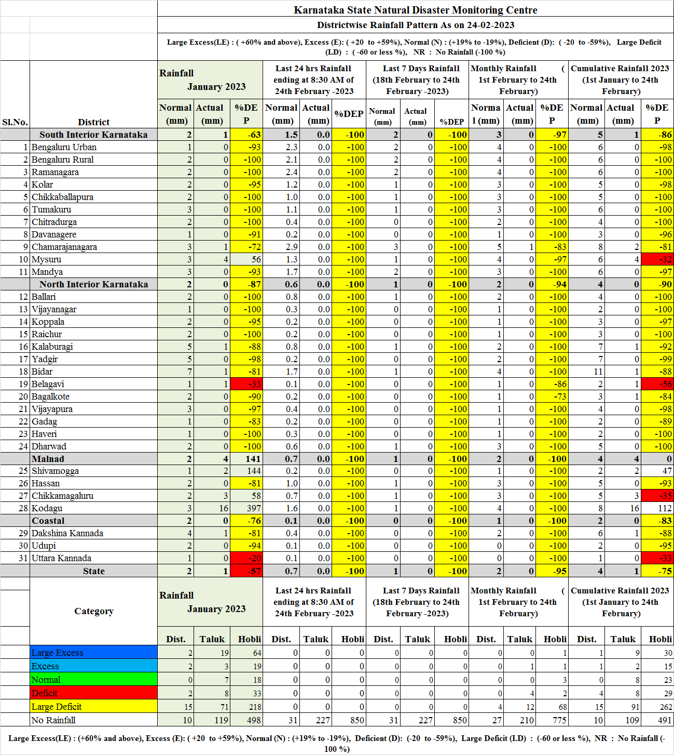
ANNEXURE -2
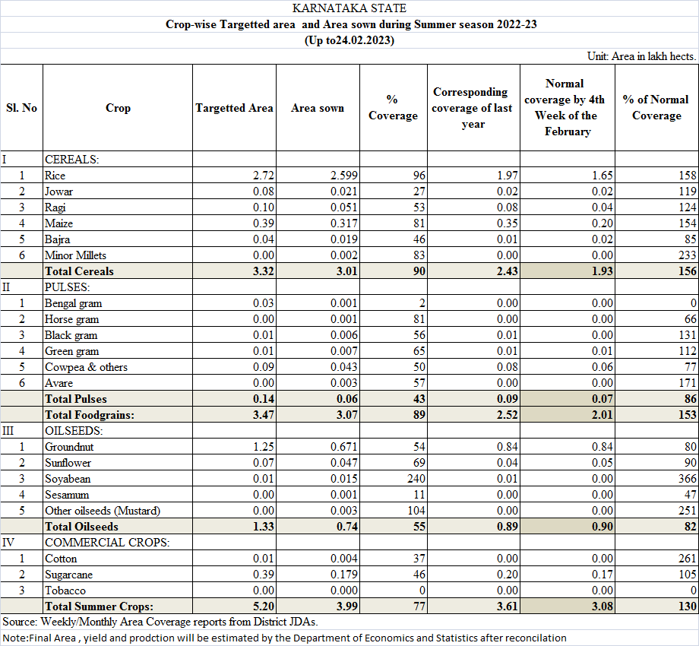
ANNEXURE -3
