Progress of sowing and agricultural crops details During Summer Season 2023-24
(03.02.2024)

2023-24 Agricultural Production:

Anticipating timely and well distributed rainfall during pre-monsoon, southwest & northeast monsoon period in 2023-24 it was programmed to cover 82.35 lakh hectares, 25.38 lakh hectares and 6.54 lakh hectares during Kharif, Rabi and Summer seasons respectively, totally 114.27 lakh hectares under agricultural crops. Proposed production target for Food grains and Oilseeds were 148.16 lakh tonnes and 13.84 lakh tonnes respectively.

Sl.No. | Crops | Area (Lakh Hectares) | Production (Lakh Tonnes)
1. | Cereals | 50.39 | 125.15
2. | Pulses | 33.84 | 23.01
 | Total Food Grains | 84.22 | 148.16
3. | Oilseeds | 13.70 | 13.84
4. | Commercial Crops
i) | Cotton | 8.16 | 24.47 Lakh Bales
ii) | Sugarcane | 7.38 | 702.64
iii) | Tobacco-VFC | 0.81 | 0.67
 | Total Area | 114.27

2023-24 Kharif Agricultural Production:

During Kharif 2023 total of 82.35 lakh hectares area has been set as target for sowing under different crops.

Sl. No. | Crops | Area (Lakh Hectares) |  | Production (Lakh Tonnes)
 |  | Targeted Area | Sown Area
1. | Cereals | 35.36 | 33.73 | 96.56
2. | Pulses | 22.13 | 17.37 | 15.36
 | Total Food Grains | 57.50 | 51.10 | 111.93
3. | Oilseeds | 9.84 | 7.97 | 9.89
4. | Commercial Crops
i) | Cotton | 8.00 | 7.06 | 24.33 Lakh Bales
ii) | Sugarcane | 6.20 | 7.35 | 607.30
iii) | Tobacco-VFC | 0.81 | 0.84 | 0.67
 | Total Area | 82.35 | 74.32
2023-24 Rabi Agricultural Production:

During Rabi 2023 total of 25.38 lakh hectares area has been set as target for sowing under different crops.

Sl.No. | Crops | Area (Lakh Hectares) |  | Production (Lakh Tonnes)
 |  | Targeted Area | Sown Area
1. | Cereals | 10.41 | 8.45 | 14.79
2. | Pulses | 11.55 | 10.86 | 7.59
 | Total Food Grains | 21.96 | 19.32 | 22.38
3. | Oilseeds | 2.53 | 1.50 | 2.62
4. | Commercial Crops
i) | Cotton | 0.15 | 0.03 | 0.11
ii) | Sugarcane | 0.74 | 0.82 | 57.49 Lakh Bales
iii) | Tobacco-VFC | 0.00 | 0.00 | 0.00
 | Total Area | 25.38 | 21.67

2023-24 Summer Agricultural Production:

During Summer 2023-24 total of 6.54 lakh hectares area has been set as target for sowing under different crops.

Sl.No. | Crops | Area (Lakh Hectares) |  | Production (Lakh Tonnes)
 |  | Targeted Area | Sown Area
1. | Cereals | 4.62 | 0.49 | 13.79
2. | Pulses | 0.15 | 0.04 | 0.06
 | Total Food Grains | 4.77 | 0.53 | 13.85
3. | Oilseeds | 1.33 | 0.50
4. | Commercial Crops |  |  | 1.34
i) | Cotton | 0.01 | 0.00 | 0.02
ii) | Sugarcane | 0.44 | 0.10 | 37.85
iii) | Tobacco-VFC | 0.00 | 0.00 | 0.00
 | Total Area | 6.54 | 1.13

Rainfall 2023:
Pre-monsoon rainfall:

During pre-monsoon (March-1 to May-31), normal average rainfall was 115 mm against actual rainfall 116 mm (1%).
Southwest monsoon rainfall:

During southwest monsoon (June-1 to September-30), normal average rainfall was 852 mm against actual rainfall 642 mm (-25%).

North-East monsoon rainfall:

During northeast monsoon (October-1 to December-30), normal average rainfall was 182 mm against actual rainfall 114 mm (-38%).

Totally (January-1st to December-30th) normal average rainfall was 1153 mm against actual rainfall 872 mm (-24%).

Rainfall 2024:

During the year 2024 (January-1 to February-3), normal average rainfall was 2 mm against actual rainfall 8 mm (265%). District wise rainfall details was provided in annexure-1.

Kharif 2023 Area coverage:

During Kharif 2023, total of 74.32 lakh hectares (90%) has been sown against a set target of 82.35 lakh hectares.

Rabi 2023 Area coverage:

During Rabi 2023, total of 21.67 lakh hectares (85%) has been sown against a set target of 25.38 lakh hectares.

Summer 2023 Area coverage:
During Summer 2023, total of 1.13 lakh hectares (17%) has been sown against a set target of 6.54 lakh hectares by 03.02.2024, Crop wise and district wise area sown details was provided in annexure 2 and 3.

2023-24 Hailstrom/Flood:

According to the joint survey report, agricultural crops were damaged in 10134.22 hectares due to Hailstorm/heavy rains in the month of March to May 2023-24.

According to the joint survey report, 101.20 hectares of agricultural crops were damaged due to hailstrom/heavy rains during the month of June 2023-24.

According to the joint survey report, agricultural crops were damaged in 7630.90 hectares due to heavy rains in the month of November.

Drought 2023:

As per Revenue Department Government Order Number: RD 449 TNR 2023, Dated: 13-09-2023, 12-10-2023 and 04-11-2023, out of 236 taluks 223 taluks are declared as drought, among which 196 taluks declared under severe category and 27 taluks under moderate category.
According to the joint survey report, 46.11 lakh hectares of agricultural crops have been damaged due to drought in the year 2023-24. Major crops of Maize (1350667.83 ha), Tur (804944.98 ha), Ragi (492514.60 ha), cotton (414314.74 ha) and soybean (365961.50 ha) are affected. Mainly in Vijayapura (464967.17 ha), Bidar (395504.00 ha), Belagavi (353885.02 ha), Kalaburagi (276368.00 ha), and Vijayanagar (269264.15 ha.) in the major crop loss are reported in the districts.

Supply of Agricultural Tools:

Seeds and fertilizer are the main agricultural commodities for farmers for distribution at Raitha Samparka Kendra (RSK) in all taluks.

Seeds:

For Rabi/Summer 2023-24, 3.80 lakh qtls seeds were estimated as demand for sowing and till dated:31.01.2024, 2.59 lakh qtls seeds have been distributed at Raitha Samparka Kendra (RSK). Remaining balance in RSK’s of 0.38 lakh qtls stock is available at RSK. Residual inventory is available at the concerned institutions.

Fertilizer:

For Rabi 2023-24, total fertilizer demand was estimated at 16.80 lakh metric tonnes of various chemical fertilizers and preparations have been made for district-wise, month-wise and organization-wise for timely supply. 18.74 lakh metric tonnes of fertilizer supplied (including initial charge), 7.94 lakh metric tonnes have been sold (up to 03.02.2024) and 10.81 lakh metric tonnes of stock available.

ANNEXURE -1
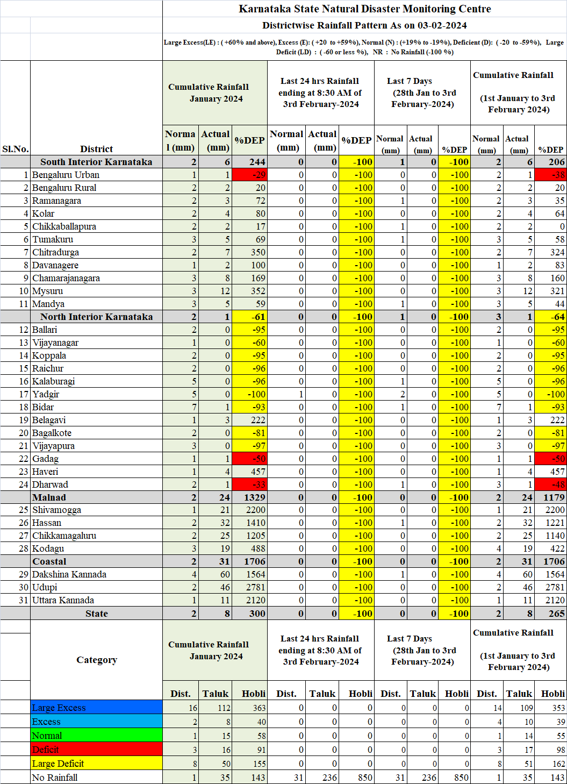
ANNEXURE -2
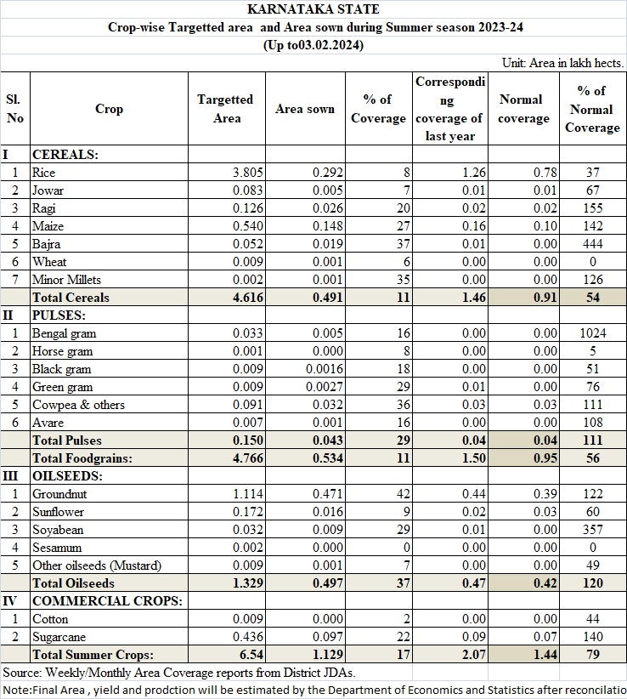
ANNEXURE -3

