Progress of sowing and agricultural crops details During Rabi Season 2022-23.
(17.12.2022)

2022-23 Agricultural Production:

Anticipating timely and well distributed rainfall during pre-monsoon, southwest & northeast monsoon period in 2022-23 it was programmed to cover 82.67 lakh hectares, 26.68 lakh hectares and 5.20 lakh hectares during Kharif, Rabi and Summer seasons respectively, totally 114.54 lakh hectares under agricultural crops. Proposed production target for Food grains and Oilseeds were 148.02 lakh tonnes and 12.69 lakh tonnes respectively.

Sl.No. | Crops | Area (Lakh Hectares) | Production (Lakh Tonnes)
1. | Cereals | 50.45 | 123.06
2. | Pulses | 35.14 | 24.96
 | Total Food Grains | 85.59 | 148.02
3. | Oilseeds | 12.64 | 12.69
4. | Commercial Crops
i) | Cotton | 7.70 | 18.75 Lakh Bales
ii) | Sugarcane | 7.87 | 403.57
iii) | Tobacco-VFC | 0.75 | 0.66
 | Total Area | 114.54

2022-23 Kharif Agricultural Production:

During Kharif 2022 total of 82.67 lakh hectares area has been set as target for sowing under different crops. Similarly, in the area of 80.40 lakh hectare sowing.

Sl.No. | Crops | Area (Lakh Hectares) |  | Production (Lakh Tonnes)
 |  | Targeted Area | Sown Area
1. | Cereals | 35.98 | 33.69 | 97.61
2. | Pulses | 22.77 | 20.39 | 17.19
 | Total Food Grains | 58.75 | 54.08 | 114.80
3. | Oilseeds | 9.37 | 10.11 | 8.70
4. | Commercial Crops
i) | Cotton | 7.28 | 8.25 | 18.42 Lakh bales
ii) | Sugarcane | 6.51 | 7.18 | 377.99
iii) | Tobacco-VFC | 0.75 | 0.78 | 0.66
 | Total Area | 82.67 | 80.40
2022-23 Rabi Agricultural Production:

During Rabi 2022 total of 26.68 lakh hectares area has been set as target for sowing under different crops.

Sl.No. | Crops | Area (Lakh Hectares) |  | Production (Lakh Tonnes)
 |  | Targeted Area | Sown Area
1. | Cereals | 11.15 | 9.24 | 14.67
2. | Pulses | 12.22 | 12.95 | 7.68
 | Total Food Grains | 23.37 | 22.19 | 22.35
3. | Oilseeds | 1.93 | 2.46 | 1.40
4. | Commercial Crops
i) | Cotton | 0.41 | 0.11 | 0.30 Lakh bales
ii) | Sugarcane | 0.97 | 0.91 | 17.01
iii) | Tobacco-VFC | 0.00 | 0.00 | 0.00
 | Total Area | 26.68 | 25.67

Rainfall:

During Rabi 2022, October-1st to December-17th normal average rainfall was 180 mm against actual rainfall 216 mm (20%).

Rabi 2022 Area coverage:
During Rabi 2022, total of 25.67 lakh hectares (96%) has been sown against a set target of 26.68 lakh hectares by 17.12.2022, Cropwise and districtwise area sown details was provided in annexure 2 and 3.

Supply of Agricultural Tools:

Seeds and fertilizer are the main agricultural commodities for farmers for distribution at Raitha Samparka Kendra (RSK) in all taluks.

Seeds:

For Rabi 2022-23, 4.32 lakh qtls seeds were estimated as demand for sowing and till dated: 16.12.2022, 3.59 lakh qtls seeds have been distributed at Raitha Samparka Kendras (RSK). Remaining balance of 0.16 lakh qtls stock is available at RSK .

Fertilizer:
For Rabi 2022-23, total fertilizer demand was estimated at 17.00 lakh metric tonnes and arrangement has been made for timely implementation at various stages till 17.12.2022 total of 7.51 lakh metric tonnes fertilizer has been supplied and the available stock is 7.54 lakh metric tonnes.

ANNEXURE -1
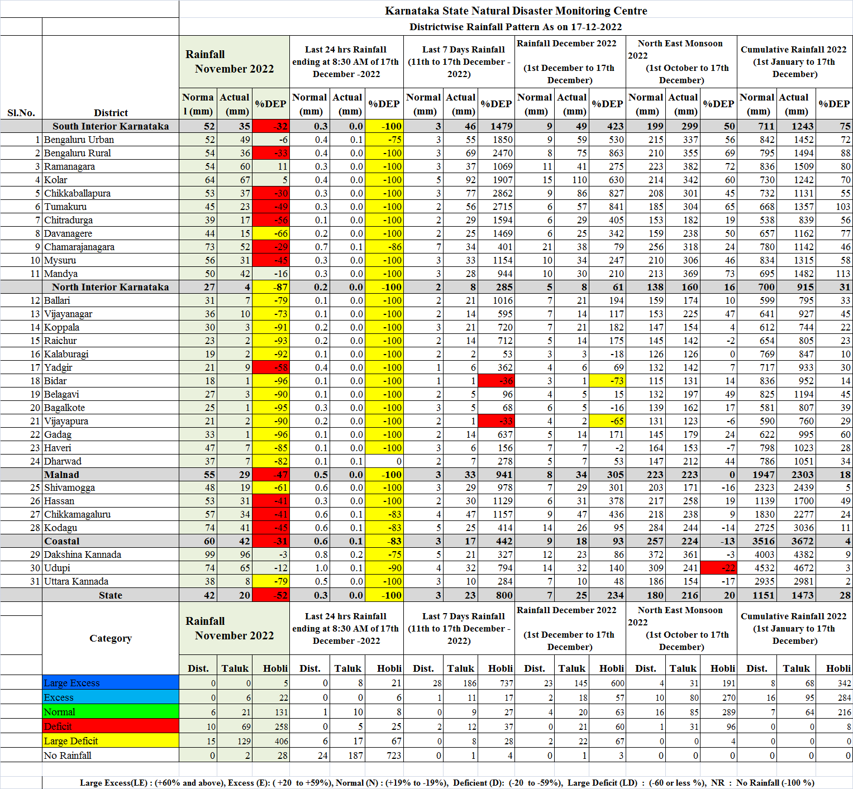
ANNEXURE -2
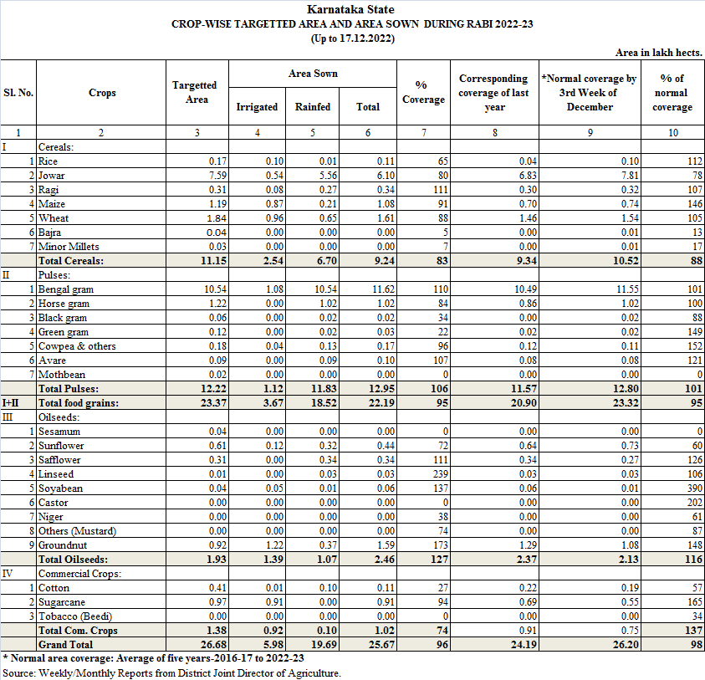
ANNEXURE -3
