Progress of sowing and agricultural crops details During Rabi Season 2023-24
(21.10.2023)

2023-24 Agricultural Production:

Anticipating timely and well distributed rainfall during pre-monsoon, southwest & northeast monsoon period in 2023-24 it was programmed to cover 82.35 lakh hectares, 25.38 lakh hectares and 6.54 lakh hectares during Kharif, Rabi and Summer seasons respectively, totally 114.27 lakh hectares under agricultural crops. Proposed production target for Food grains and Oilseeds were 148.16 lakh tonnes and 13.84 lakh tonnes respectively.

Sl.No. | Crops | Area (Lakh Hectares) | Production (Lakh Tonnes)
1. | Cereals | 50.39 | 125.15
2. | Pulses | 33.84 | 23.01
 | Total Food Grains | 84.22 | 148.16
3. | Oilseeds | 13.70 | 13.84
4. | Commercial Crops
i) | Cotton | 8.16 | 24.47 Lakh Bales
ii) | Sugarcane | 7.38 | 702.64
iii) | Tobacco-VFC | 0.81 | 0.67
 | Total Area | 114.27

2023-24 Kharif Agricultural Production:

During Kharif 2023 total of 82.35 lakh hectares area has been set as target for sowing under different crops.

Sl. No. | Crops | Area (Lakh Hectares) |  | Production (Lakh Tonnes)
 |  | Target | Acht. (30.09.2023)
1. | Cereals | 35.36 | 33.73 | 96.56
2. | Pulses | 22.13 | 17.37 | 15.36
 | Total Food Grains | 57.50 | 51.10 | 111.93
3. | Oilseeds | 9.84 | 7.97 | 9.89
4. | Commercial Crops
i) | Cotton | 8.00 | 7.06 | 24.33 Lakh Bales
ii) | Sugarcane | 6.20 | 7.35 | 607.30
iii) | Tobacco-VFC | 0.81 | 0.84 | 0.67
 | Total Area | 82.35 | 74.32
2023-24 Rabi Agricultural Production:

During Rabi 2023 total of 25.38 lakh hectares area has been set as target for sowing under different crops.

Sl.No. | Crops | Area (Lakh Hectares) |  | Production (Lakh Tonnes)
 |  | Targeted Area | Sown Area
1. | Cereals | 10.41 | 2.62 | 14.79
2. | Pulses | 11.55 | 4.96 | 7.59
 | Total Food Grains | 21.96 | 7.58 | 22.38
3. | Oilseeds | 2.53 | 0.43 | 2.62
4. | Commercial Crops
i) | Cotton | 0.15 | 0.02 | 0.11
ii) | Sugarcane | 0.74 | 0.25 | 57.49 Lakh Bales
iii) | Tobacco-VFC | 0.00 | 0.00 | 0.00
 | Total Area | 25.38 | 8.28

Rainfall:

During Rabi 2023, October-1st to October-21st normal average rainfall was 97 mm against actual rainfall 40 mm (-59%).

Rabi 2023 Area coverage:
During Rabi 2023, total of 8.28 lakh hectares (33%) has been sown against a set target of 25.38 lakh hectares by 21.10.2023, Cropwise and Districtwise area sown details was provided in annexure 2 and 3.

Supply of Agricultural Tools:

Seeds and fertilizer are the main agricultural commodities for farmers for distribution at Raitha Samparka Kendra (RSK) in all taluks.

Seeds:

For Rabi/Summer 2023-24, 3.75 lakh qtls seeds were estimated as demand for sowing and till dated:21.10.2023, 1.06 lakh qtls seeds have been distributed at Raitha Samparka Kendra (RSK). Remaining balance in RSK’s of 0.80 lakh qtls stock is available at RSK. Residual inventory is available at the concerned institutions.

Fertilizer:

For Rabi 2023-24, total fertilizer demand was estimated at 3.26 lakh metric tonnes and available stock is 10.68 lakh metric tonnes, 1.68 lakh metric tonnes have been sold (up to 21.10.2023) and remaining stock is 9.00 lakh metric tonnes.

ANNEXURE -1
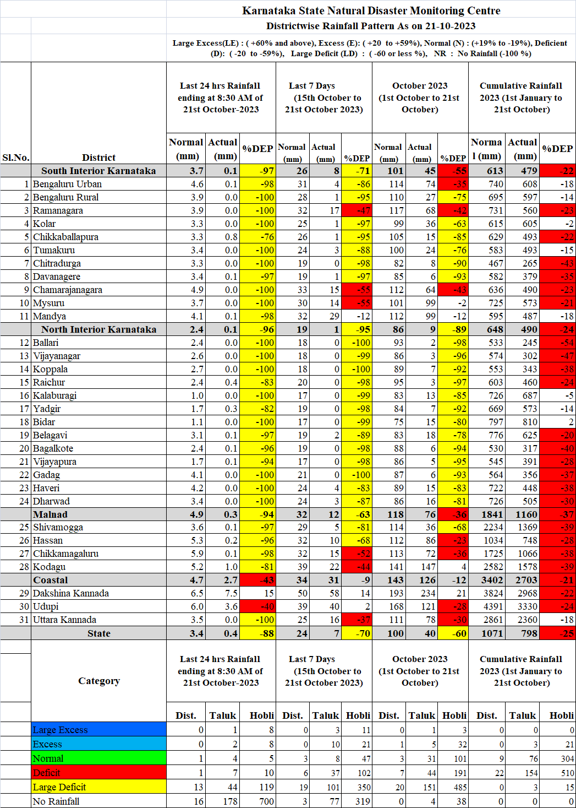

ANNEXURE -2
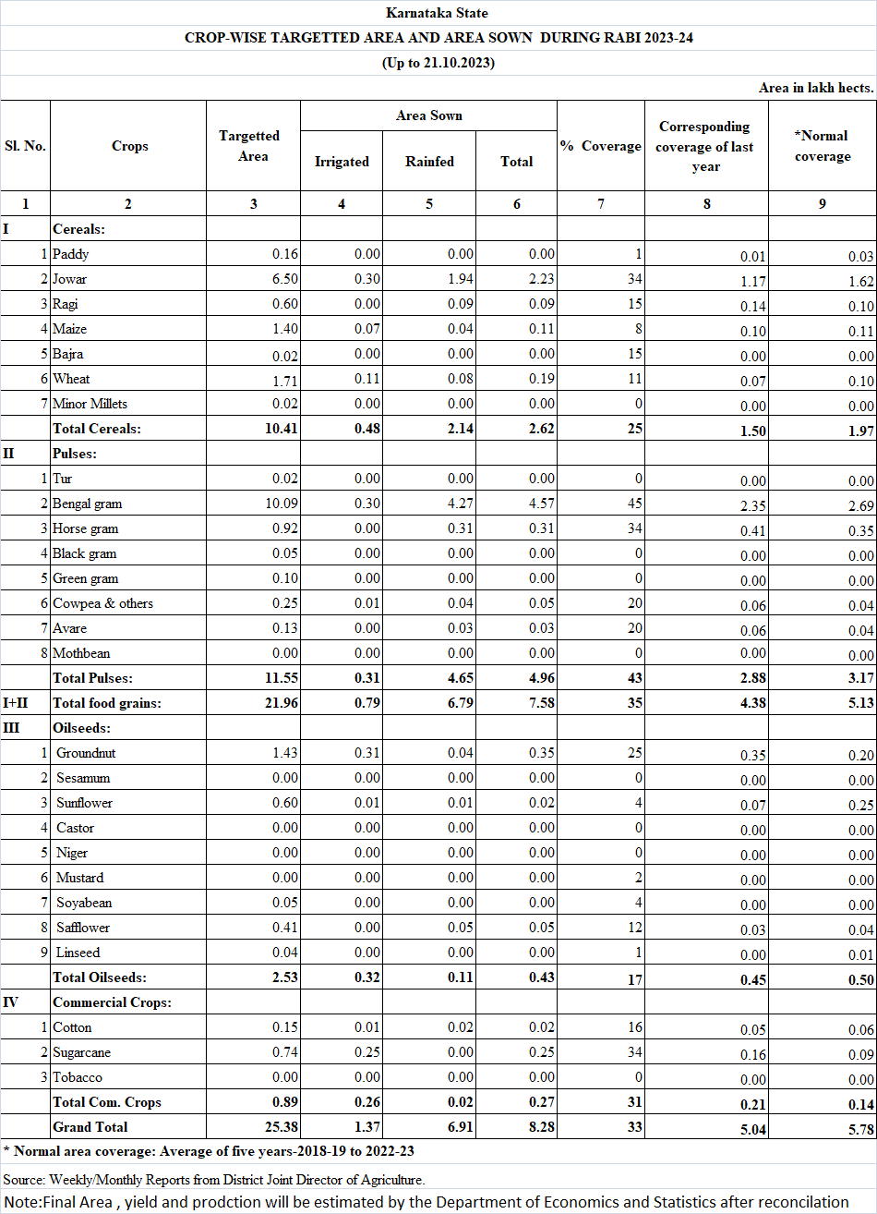
ANNEXURE -3
