2023-24 Kharif Season Progress of Agriculture crop sowing and Rainfall Details
(25.08.2023)

2023-24 Agricultural Production:

Anticipating timely and well distributed rainfall during pre-monsoon, southwest & northeast monsoon period in 2023-24 it was programmed to cover 82.35 lakh hectares, 25.38 lakh hectares and 6.54 lakh hectares during Kharif, Rabi and Summer seasons respectively, totally 114.27 lakh hectares under agricultural crops. Proposed production target for Food grains and Oilseeds were 148.16 lakh tonnes and 13.84 lakh tonnes respectively.

Sl.No. | Crops | Area (Lakh Hectares) | Production (Lakh Tonnes)
1. | Cereals | 50.39 | 125.15
2. | Pulses | 33.84 | 23.01
 | Total Food Grains | 84.22 | 148.16
3. | Oilseeds | 13.70 | 13.84
4. | Commercial Crops
i) | Cotton | 8.16 | 24.47 Lakh Bales
ii) | Sugarcane | 7.38 | 702.64
iii) | Tobacco-VFC | 0.81 | 0.67
 | Total Area | 114.27

2023-24 Kharif Agricultural Production:

During Kharif 2023 total of 82.35 lakh hectares area has been set as target for sowing under different crops.

Sl. No. | Crops | Area (Lakh Hectares) |  | Production (Lakh Tonnes)
 |  | Target | Acht. (25.08.2023)
1. | Cereals | 35.36 | 27.80 | 96.56
2. | Pulses | 22.13 | 16.63 | 15.36
 | Total Food Grains | 57.50 | 44.43 | 111.93
3. | Oilseeds | 9.84 | 7.94 | 9.89
4. | Commercial Crops
i) | Cotton | 8.00 | 6.60 | 24.33 Lakh Bales
ii) | Sugarcane | 6.20 | 6.90 | 607.30
iii) | Tobacco-VFC | 0.81 | 0.81 | 0.67
 | Total Area | 82.35 | 66.68

During pre-monsoon period between April to May in view of agricultural activities in the state, districts such as Chamarajanagara, Mandya, Hassan, Chikkamangaluru, Tumkur, Koppal, Ramanagara, Mysuru and Chitradurga at various places land preparation as been done. Area as been sown under jowar, greengram, blackgram, cowpea, sesamum, sunflower, cotton, etc.

In Coastal, Malnad, South Interior Karnataka and North Interior Karnataka region, after south west monsoon commenced land preparation and sowing activities have been started.

Pre-Monsoon Rainfall:

During 2023-24 normal Pre-monsoon rainfall (March-1 to May-31) was 115 mm against actual rainfall 116 mm (1%).

South west Monsoon Rainfall:

Normal rainfall (June 1st to August 25th) was 660 mm against actual rainfall 488 mm (-26%).

Total Rainfall (1st January – 25th August) the normal rainfall was 779 mm against actual rainfall is 605 mm (-22%).
Sowing progress and status of agricultural crops:

During Early Kharif 2023 total of 2.48 lakh hectares (84%) has been sown against a set target of 2.95 lakh hectares.

During Kharif 2023 total of 66.68 lakh hectares (81%) has been sown against a set target of 82.35 lakh hectares by 25.08.2023, Crop wise and district wise area sown details was provided in annexure 2 and 3.

Seeds:

For Kharif 2023-24, 5.55 lakh qtls seeds were estimated as demand for sowing and till dated:25.08.2023, 3.38 lakh qtls seeds have been distributed at Raitha Samparka Kendra (RSK). Remaining balance in RSK’s of 72949 qtls stock is available at RSK. Residual inventory is available at the concerned institutions.

Fertilizer:

For Kharif 2023-24, total fertilizer demand was estimated at 25.47 lakh metric tonnes and available stock is 33.21 lakh metric tonnes, 19.90 lakh metric tonnes have been sold (up to 25.08.2023) and remaining stock is 13.31 lakh metric tonnes.

Annexure-1
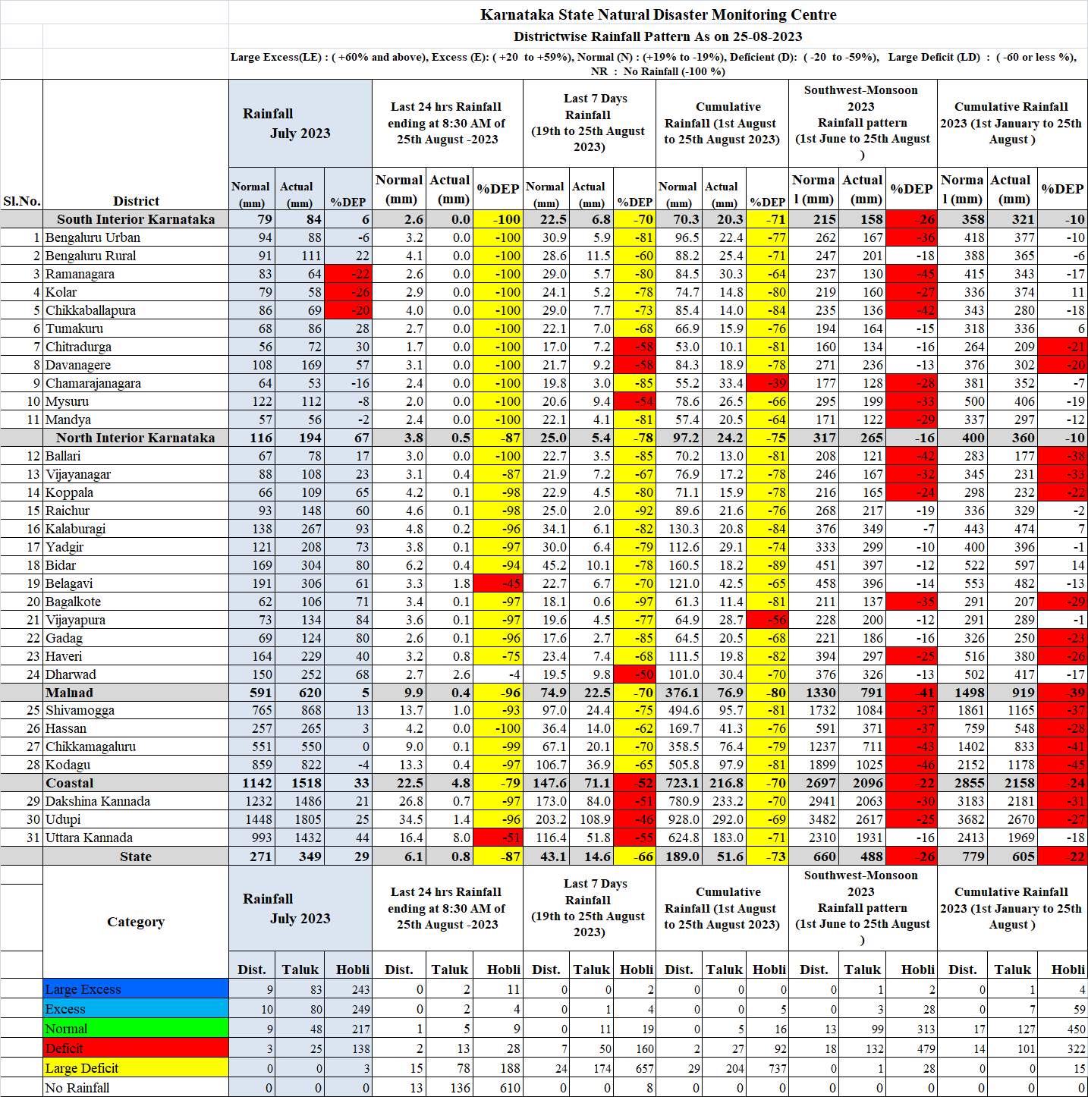
Annexure-2
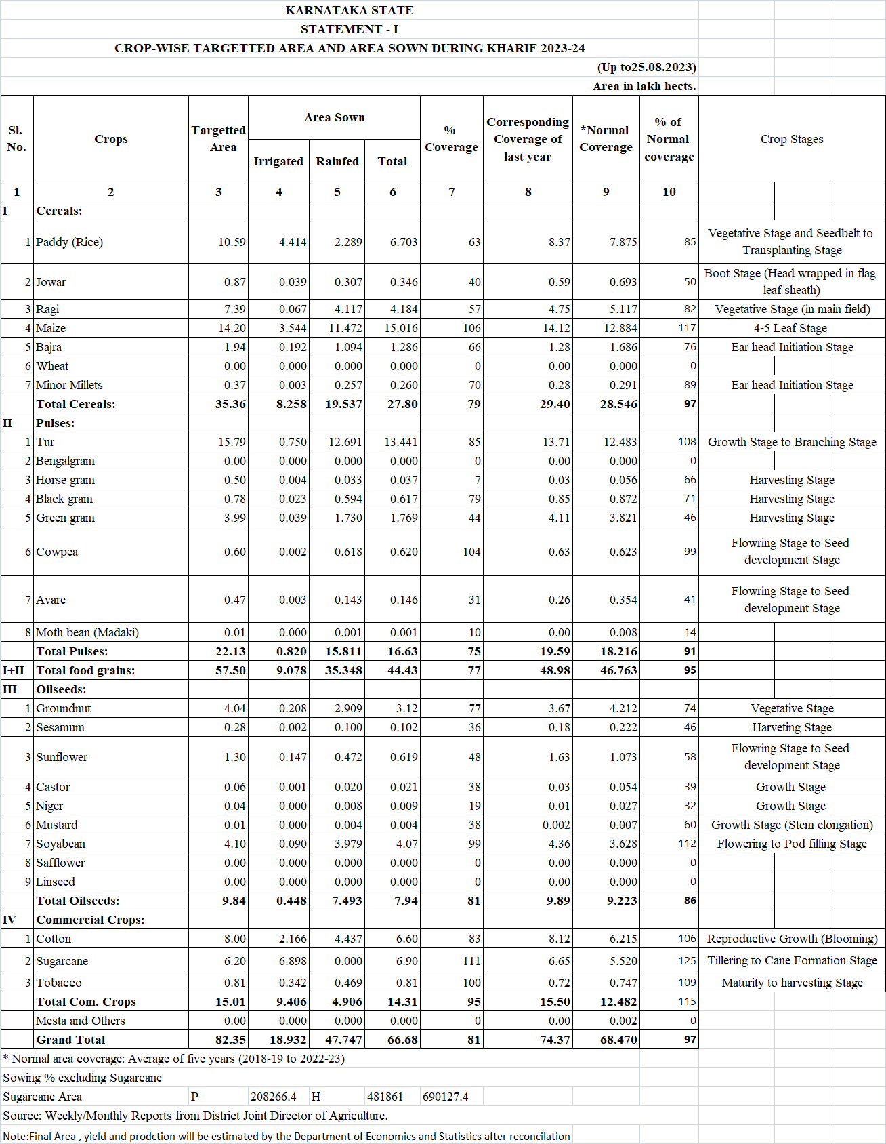
Annexure-3
