During Early Kharif Season 2022-23 Progress of sowing and agricultural crops Details.
(27.05.2022)

Annexure-1
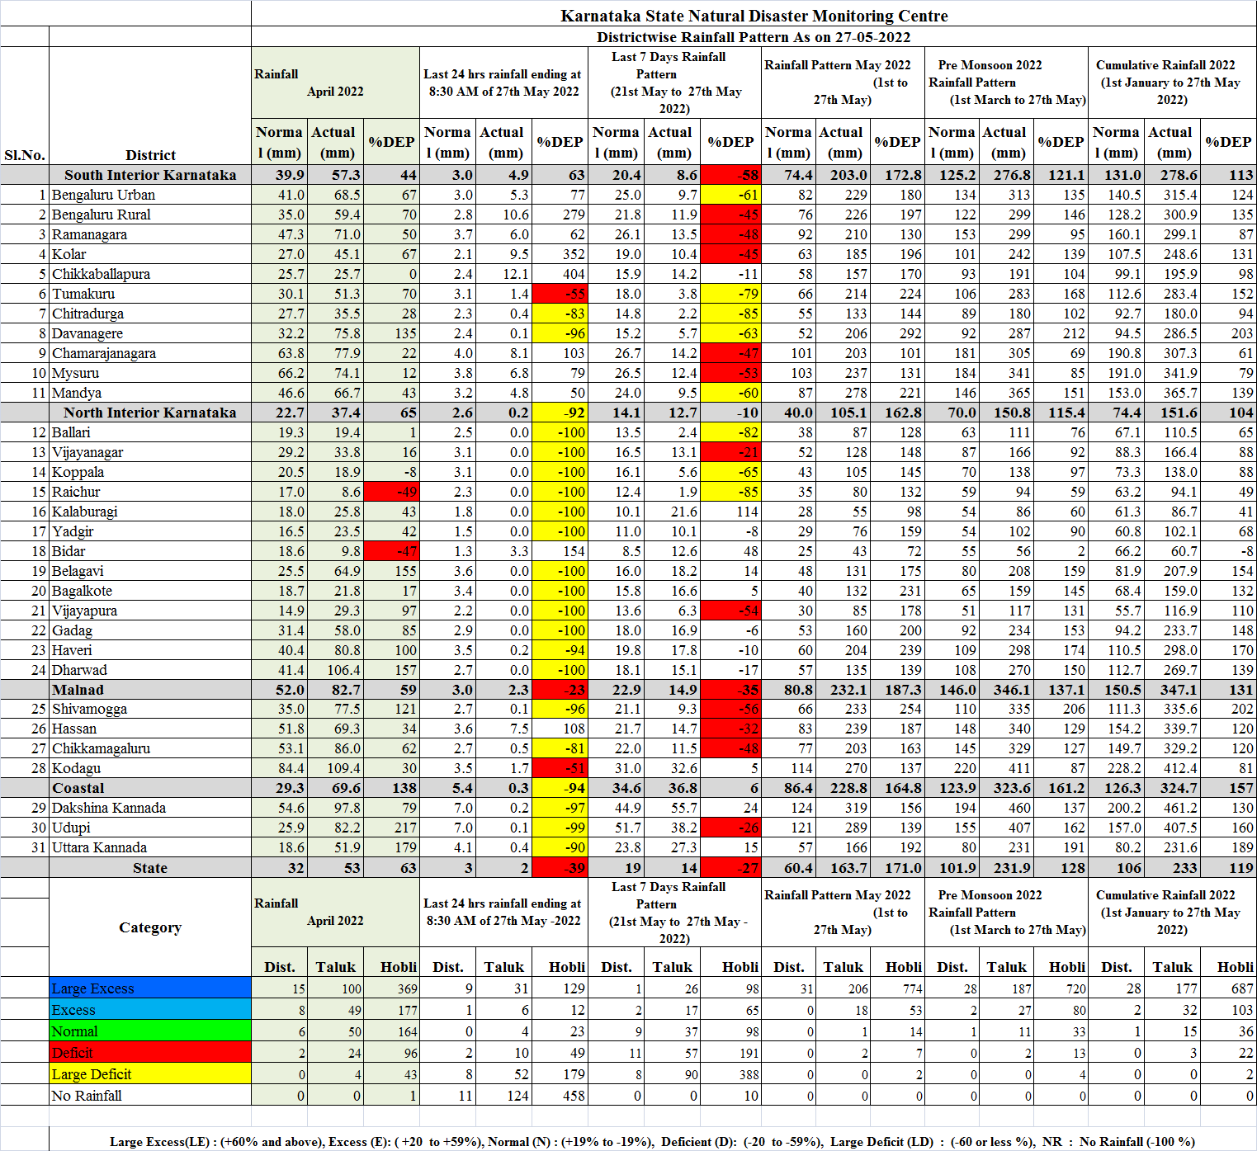
Annexure-2
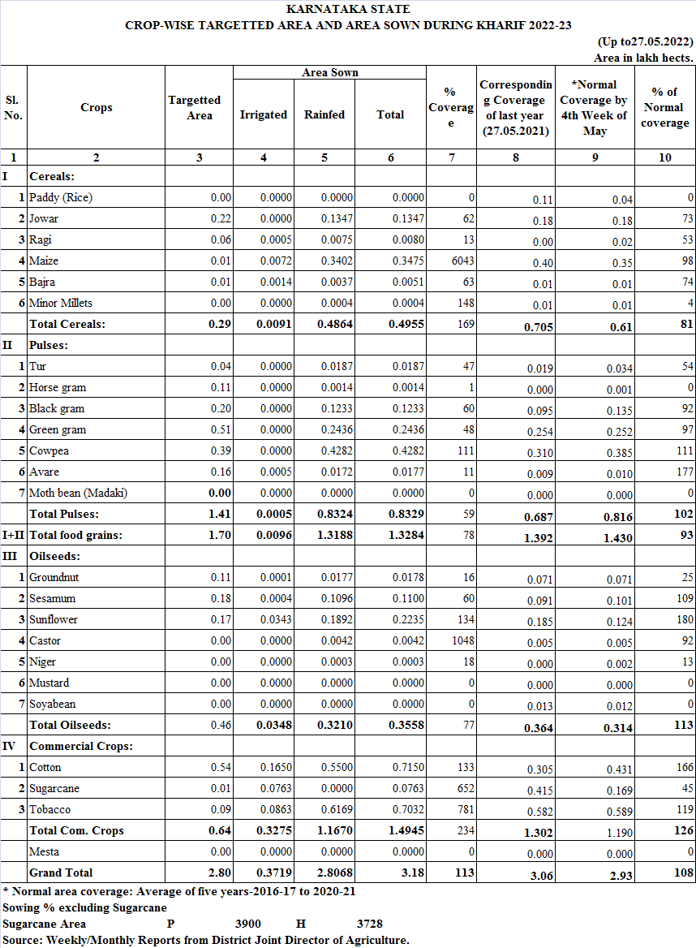
Annexure-3
