2023-24 Pre-Kharif Area Sown and Rainfall Data

ANNEXURE -1
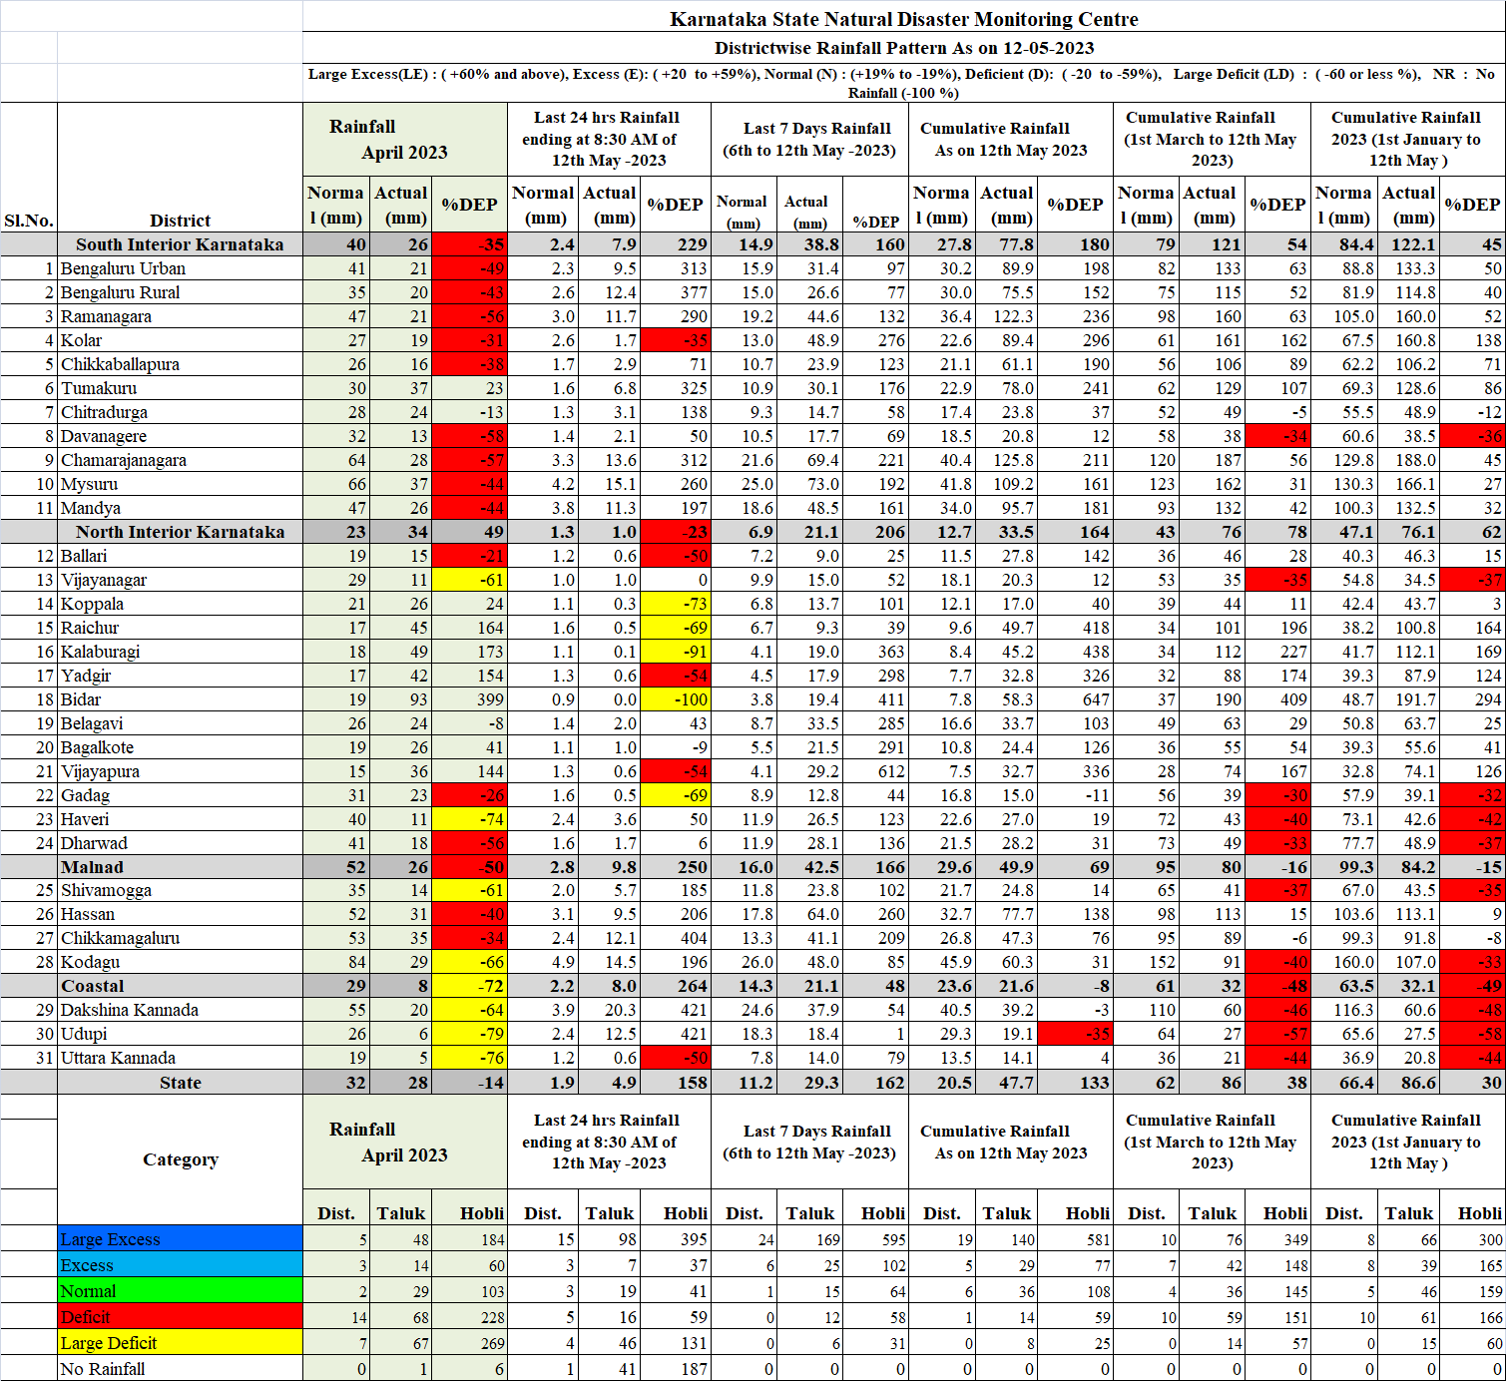
Crop-wise Targeted Area and Area sown during Pre-Kharif 2023-24

ANNEXURE -2
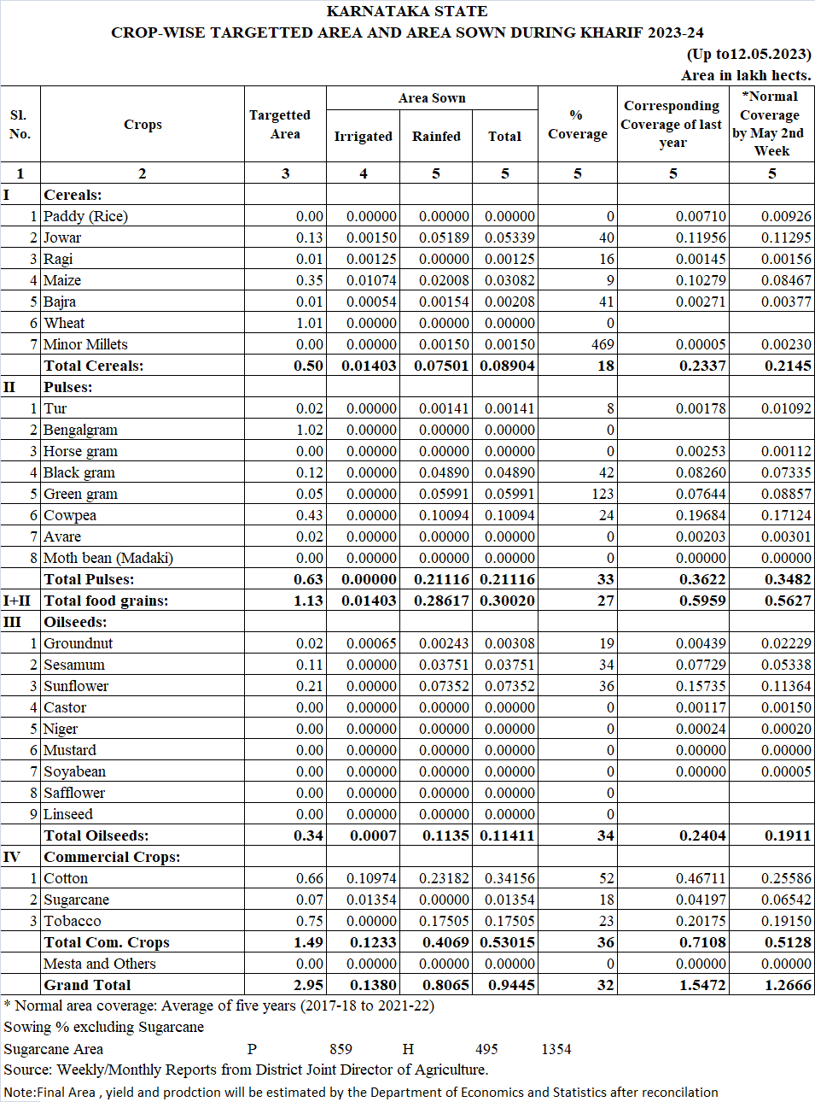

District-wise Targeted Area and Area sown during Pre-Kharif 2023-24

ANNEXURE -3

