Early Kharif 2022-23 Area Sown Details as on 22.04.2022
Annexure-1
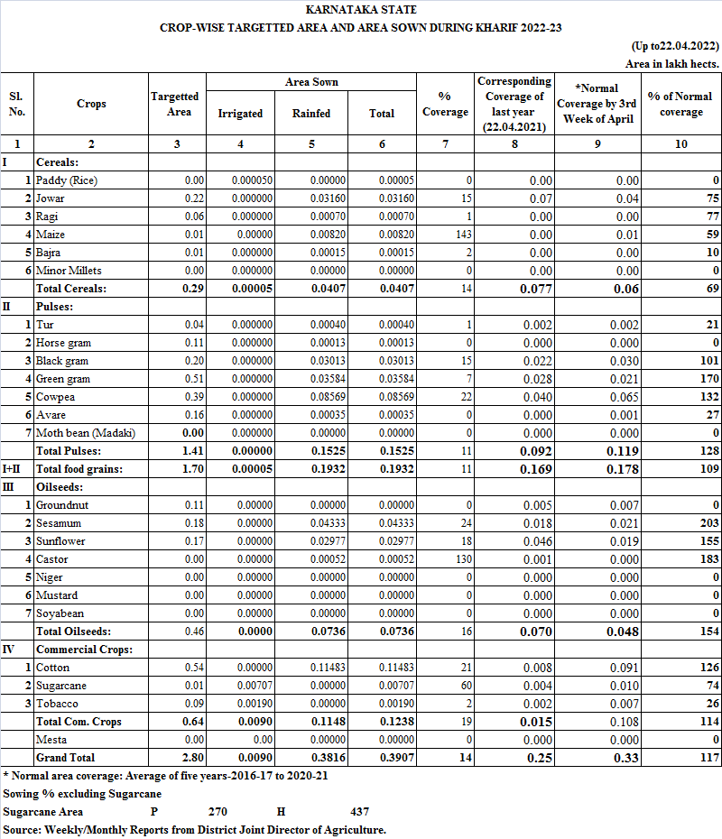
Annexure-2
