2022-23 Early Kharif Area Sown Details as on 13.05.2022
Annexure-1
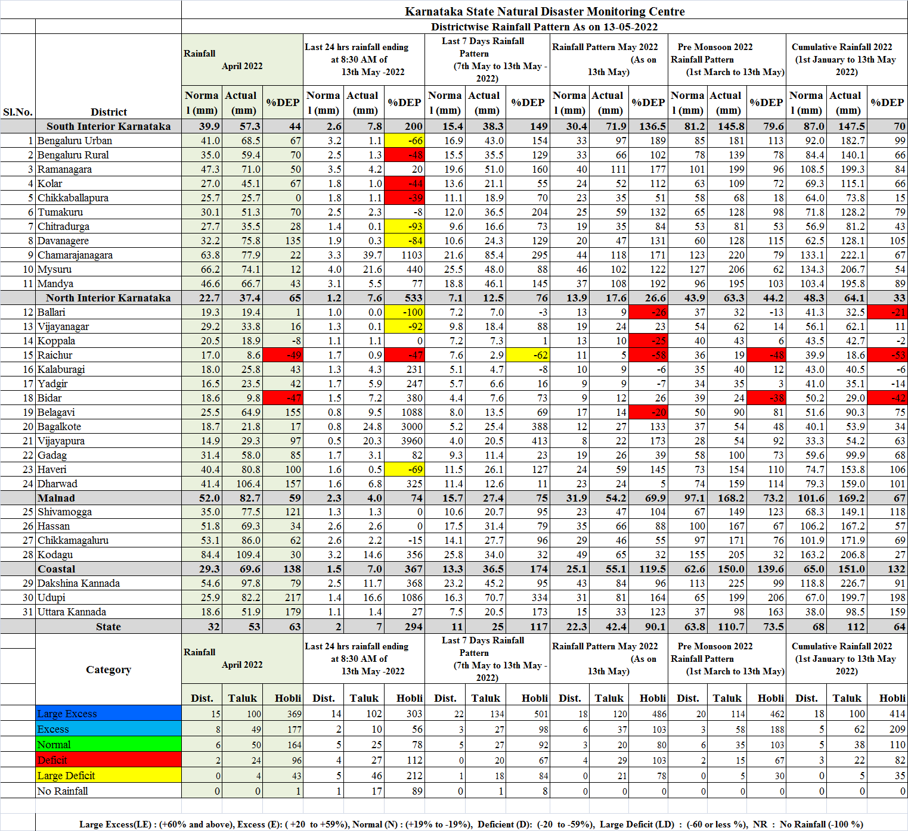
Annexure-2
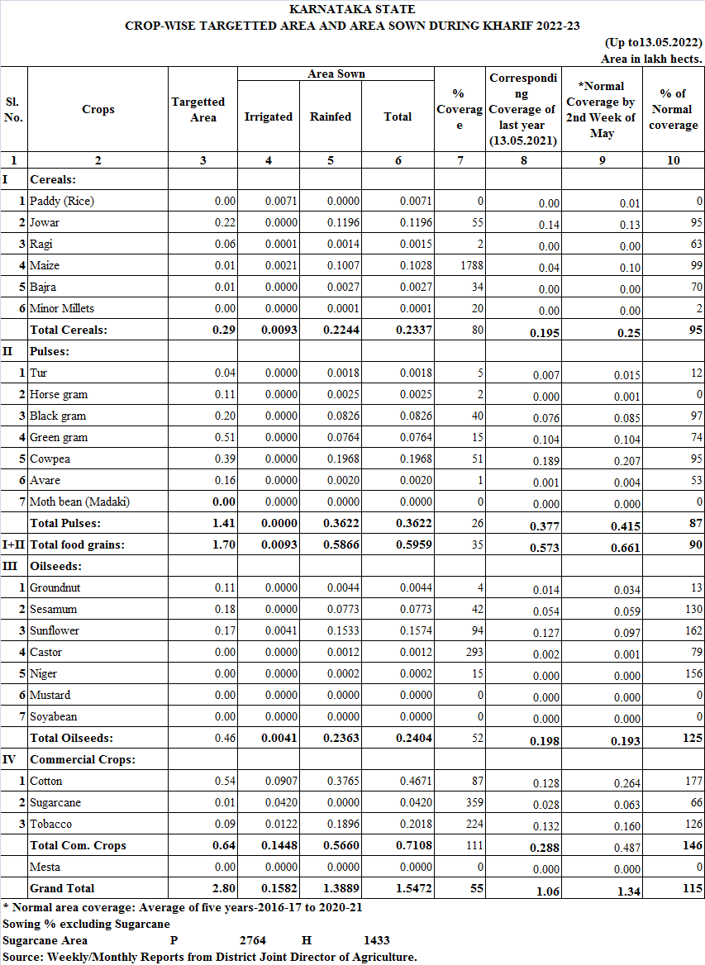
Annexure-3
